 | International Journal of | 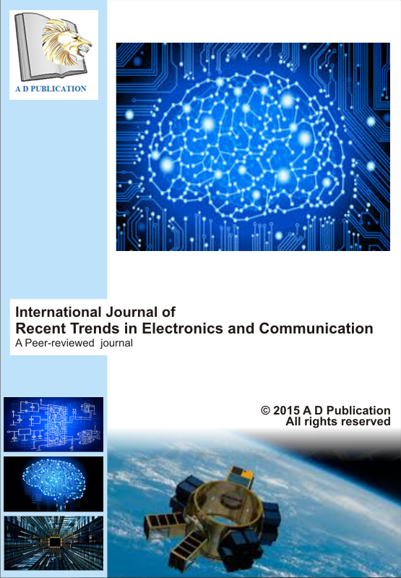
Recent Trends in Electronics and Communication
A Peer-reviewed journal
 | IJRTEC XX (2016) XXX-XXX
Paper title in 14 size Arial bold
Corresponding author ^{1*}, other author ²( 11 size Arial)

¹Department name, college, country ( 10 size Arial)

²Department name, college, country ( 10 size Arial)

A B S T R A C T : | The abstract should summarize the content of the paper. Try to keep the abstract below 200 words. Do not make references nor display equations in the abstract. The journal will be printed from the same-sized copy prepared by you. Your manuscript should be printed on A4 paper .This will enable us to keep uniformity in the final printed copies of the Journal. Please keep in mind that the manuscript you prepare will be photographed and printed as it is received. Readability of copy is of paramount importance (Abstract in 9 size Arial line spacing 1 )  © 2016 A D Publication. All rights reserved
Keywords: | 4 Key words in 9 size Arial
- Introduction ( 11 size Arial bold)

All manuscripts must be in English. These guidelines include complete descriptions of the fonts, spacing, and related information for producing your proceedings manuscripts. (10 size Arial with 1.15 line spacing)

2. First-order headings (11 size Arial bold)

First order heading should be 11 size Arial bold with 1.15 line spacing, initially capitalized, flush left, with one blank line before, and one blank line after.

2.1. Second-order headings (10 size Arial bold)
Second order heading should be 10 size Arial bold with 1.15 line spacing, initially capitalized, flush left, with one blank line before, and one blank line after.

2.1.1. Third-order headings. (10 size Arial bold)
Third order heading should be 10 size Arial bold with 1.15 line spacing, initially capitalized, flush left, with one blank line before, and one blank line after.
In second page write all nomenclature used in manuscript.

Nomenclature

X | Name of parameter
Y | Name of parameter
Z | Name of parameter
A | Name of parameter
B | Name of parameter
C | Name of parameter
D | Name of parameter
,

3. Tables and fig. (11 size Arial bold)

Table 1 Data table

Sr. No. | Margin | Value
1 | Left | 0.8"
2 | Right | 0.8"
3 | Top | 0.8"
4 | Bottom | 1.0"

To ensure a high-quality product, diagrams and lettering MUST be either computer-drafted .Figure captions appear below the figure, are flush middle, and are in lower case letters. When referring to a figure in the body of the text, the abbreviation "Fig." is used. Figures should be numbered in the order they appear in the text. Figure is in centre with figure number at bellow centrally justified 8 size Arial font.
Table captions appear centered above the table in upper and lower case letters. When referring to a table in the text uses "Table" with number and name. (10 size Arial with 1.15 line spacing)

Conclusion (11 size Arial bold)
A conclusion section must be included and should indicate clearly the advantages, limitations, and possible applications of the paper. Although a conclusion may review the main points of the paper, do not replicate the abstract as the conclusion. A conclusion might elaborate on the importance of the work or suggest applications and extensions. (10 size Arial with 1.15 line spacing)

Acknowledgements (11 size Arial bold)
An acknowledgement section may be presented after the conclusion, if desired. (10 size Arial with 1.15 line spacing)

Reference

The template will number citations consecutively within brackets [1]. The sentence punctuation follows the bracket [2]. Refer simply to the reference number, as in [3]—do not use “Ref. [3]” or “reference [3]”
For papers published in translation journals, please give the English citation first, followed by the original foreign-language citation [6].

Format of Reference
Journal Papers:

- Author1, Author2, "Paper Title", Journal Name with Issue number, Page Number, Year of Publish (09 size Arial with 1.00 line spacing)
Books:

- P.A. Chang, Interval analysis (Englewood Cliffs, NJ: Prentice-Hall, 1966). (09 size Arial with 1.00 line spacing)

\
Chapters in Books:
- P.O. Bishop, Neurophysiology of binocular vision, in J.Houseman (Ed.), Handbook of physiology, 4 (New York: Springer-Verlag, 19650) 323-332. (09 size Arial with 1.00 line spacing)

Theses:

- D.S. Chan, Theory and implementation of multidimensional discrete systems for signal processing, doctoral diss., Massachusetts Institute of Technology, Cambridge, MA, 1978. (09 size Arial with 1.00 line spacing)

Proceedings Papers:
- X.Y.Zaer, Digital System: A tutorial review, Proc. 24th IEEE Conf. on Digital System, San Francisco, CA, 1980, 345-355. (09 size Arial with 1.00 line spacing)

